# 

# 

# 

Diffusion Chamber Proposal

Jan 29th, 2021

Bach Doan (251046862)

Nafiz Mizan (250900352)

Soran Ismail (251039303)

# 

# **Goal**

To design a cooling system that automatically adjusts and maintains the temperature of a 4 cm x 28 cm (diameter x length) cylinder.

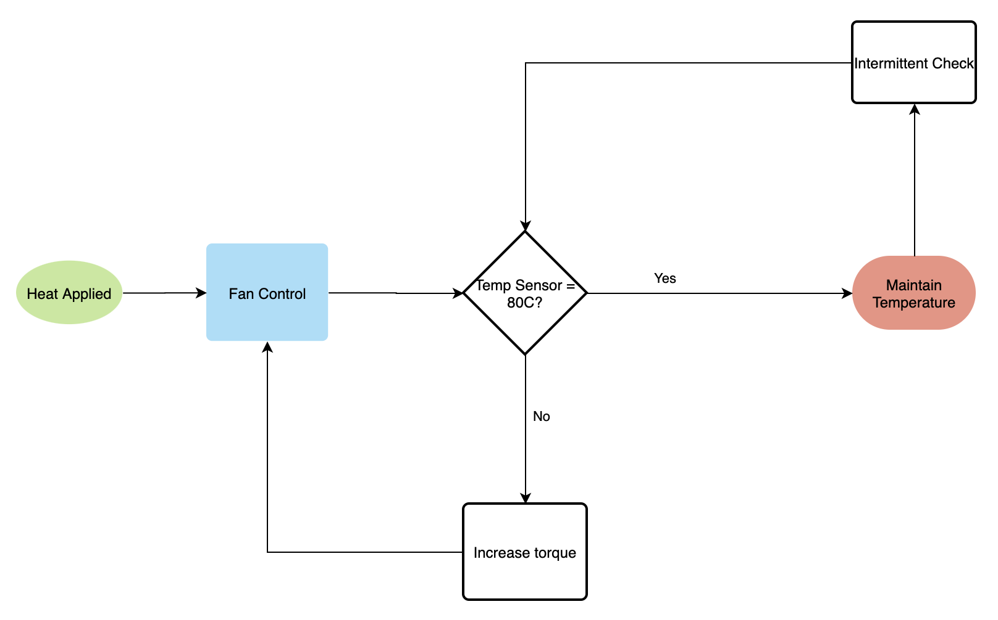

# **Heating Sources**

Heat sources are used to simulate a testing environment. The heat sources must be able to provide a temperature of 80 C and higher. Accessible heat sources are heat guns and hair dryers. These devices can generate between 80 to 500 C. In order to operate, these devices will need access to a power outlet.

*Common specifications:*

Power Supply: 120 VAC

Power Consumption: 1800 Watts

*Example:*

**

# **Fans**

Fans are used to cool down the temperature that was created by the heat sources. The speed of the fan needs to vary based on the temperature of the cylinder. Computer fans can be used to cool down the temperature of small surface areas. The temperature that a computer fan is capable of cooling down is unknown and will need to be tested.

.*Common specifications:*

Power Supply: 24 VDC

Current Required: 50 mA

Power Consumption: 1.2 W

*Example:*

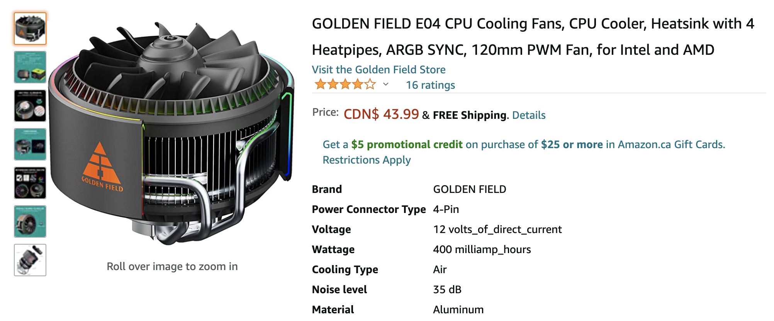

Third-party Arduino DC motors can also be used to create fans. The motor can be attached to a mechanism with blades, and powered by the 9V battery to spin and cool down the temperature in the diffusion box. The RPM of the motor can be controlled through the Arduino to change the amount of hot air being blown out.

*Common specifications:*

Power Supply: 12 VDC

Current Required: 400 - 500 mA

Power Consumption: 4800 - 6000 mW/hour

# **Temperature Sensors**

The temperature sensing we will use is through a thermistor, which is a resistor that changes resistance based on temperature, and therefore, the controller can take an analog input.

The Arduino is equipped with an analog to digital converter (ADC) with a resolution of 10 bits (0-1023).

# **Current Sensors**

The use of a current sensor as an analog input into the microcontroller may be useful to understand the torque vs current relationship in the fan. This could be used to control fan speed instead of PWM.

A hall-effect sensor will be used to measure currents and provide analog value to the microcontroller.

**Buck and Boost Converter**

***Buck Converter*** will be used to step-down the voltage to supply DC voltage to the microcontroller (5V), and other components.

***Boost Converter*** will be used to step-up voltage to power the fan (24V).

# **Voltage Divider, Current-Voltage Converter, Amplifier**

***Voltage dividers*** are used to divide larger voltages into smaller voltages using resistors. According to the Arduino website, many of the temperature sensors run at around 5 V. Many of the third party parts we found also run around 3-5 V (example from Amazon shown below). This concept may be useful to lower the voltage from the 9V battery to a working voltage.

***Amplifiers*** magnify signals using passive and active components. An amplifier could be used to amplify the output of the temperature sensor to ensure that we get a more accurate reading.

***Current-Voltage Converters*** convert currents to voltages. At this point, we do not believe we have a use for this concept because we are dealing with a very low current as it is.

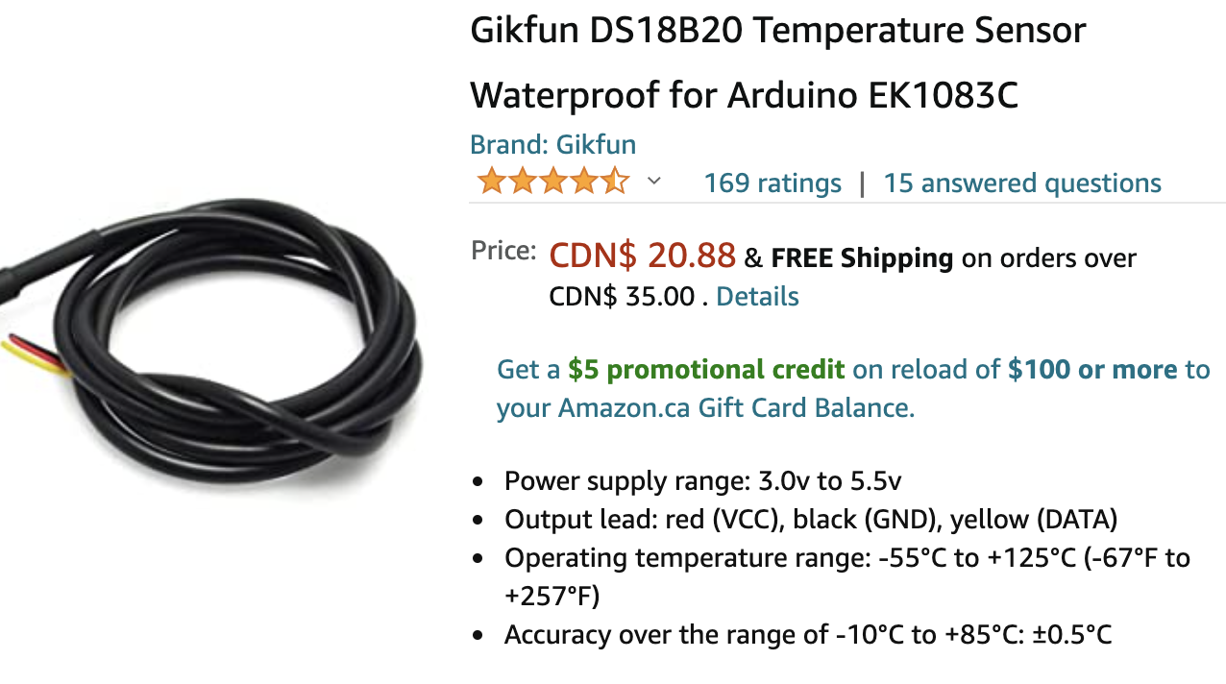

[nafiz.mizan@gmail.com](mailto:nafiz.mizan@gmail.com) do you wanna keep this picture, cuz idk where it should go?

# 